Operlytics: Development and Evaluation of a Business Analytics and Monitoring System for Improving Operational Decision-Making.

In partial fulfillment for the requirements in Capstone 1 and Research Subject

ARCIDO, JOHN MICHAEL BSIT 3 - 2
NAVARRO, MAY ANN JOY BSIT 3 - 2
PENIERO, SEAN BSIT 3 - 2
SALE, NAZZER SAMUEL BSIT 3 - 2
ZERESO, KURTH JAY BSIT 3 - 2

Business Track

Second Semester
e.g MARCH 2026

CHAPTER 1

INTRODUCTION

1.1 Background of the Study

The food service and hospitality industry is one of the most dynamic and competitive sectors in the global economy. Small and medium-sized enterprises (SMEs) in the food service sector contribute significantly to local employment and GDP, particularly in tourism-dependent economies (ILO, 2022). Despite their economic significance, many of these establishments face persistent operational and managerial challenges that hinder their long-term sustainability and growth.

In the Philippines, the food service industry plays a critical role in both national and local economies. Boracay Island, consistently ranked among the top beach destinations in Southeast Asia, attracts millions of tourists each year, placing considerable demand on local food service establishments to deliver high-quality products and services. Small business owners in this environment must balance customer satisfaction with efficient operational management — a challenge compounded by limited resources, workforce constraints, and the absence of formal business management systems.

One of the most common operational challenges faced by small cafés is the reliance on manual and informal methods for managing day-to-day activities. Many establishments still record sales by hand, track inventory using paper logbooks, and generate reports through ad hoc processes that are prone to human error and inconsistency. These practices produce unreliable data that limits management's capacity to make sound operational and financial decisions. Research has consistently shown that the absence of structured information systems contributes to poor inventory control, undetected losses, and inefficient resource allocation — problems that are particularly severe in fast-paced service environments (Laudon & Laudon, 2020; O'Brien & Marakas, 2018).
This situation is clearly evident in the case of Empress Café Boracay, a small café operating within the highly competitive tourism-driven market of Boracay Island. The café currently relies on manual and inconsistent methods for managing its core operations, including sales monitoring, inventory tracking, and financial reporting. Staff members record sales individually without a centralized system, resulting in data fragmentation and frequent discrepancies between actual and recorded inventory levels. The absence of real-time data visibility makes it difficult for management to identify trends, monitor supply movement, and anticipate stock shortages. These gaps have led to instances of overstocking, unnecessary waste, and customer service delays — all of which negatively affect the café's profitability and service quality.

The increasing accessibility of information and communications technology (ICT) has opened new opportunities for small businesses to adopt digital tools that streamline operations and improve decision-making. Business analytics systems have emerged as powerful instruments for transforming raw operational data into actionable insights, automatically aggregating data, presenting information through intuitive dashboards, and generating reports with minimal manual input. Research demonstrates that businesses leveraging analytics tools are significantly more likely to identify inefficiencies, reduce costs, and respond effectively to changing market conditions (Davenport & Harris, 2017; Wixom et al., 2021). For small businesses in tourism-intensive environments, adopting such systems is increasingly a necessity rather than a luxury.

In response to these challenges, this study proposes the development and implementation of Operlytics, a business analytics and monitoring system specifically designed for Empress Café Boracay. Operlytics aims to provide café management with a comprehensive, real-time view of key operational metrics — including sales transactions, inventory levels, product performance, and overall business activity. By automating data collection and reporting, the system seeks to eliminate inefficiencies associated with manual record-keeping, reduce human error, and equip management with reliable information for sound decision-making. Designed with usability in mind, it requires no advanced technical expertise from its users.
The significance of this study extends beyond Empress Café Boracay. By demonstrating the feasibility of a tailored analytics system in a small café setting, this research contributes to the broader discourse on the digital transformation of micro and small enterprises in the Philippines, and highlights technology-driven solutions for businesses operating in tourism-dependent localities where operational demands are often seasonal, unpredictable, and high-volume. Ultimately, Operlytics represents a meaningful step toward empowering small business owners with the tools needed to optimize operations, improve service quality, and achieve long-term sustainability in an increasingly competitive marketplace.

1.2 Statement of the Problem
General Problem Statement
Effective operational systems are crucial in managing sales transactions, inventory levels, and business reports in any food service establishment. In the context of small cafés operating within highly competitive and tourism-driven environments, the ability to maintain accurate, consistent, and real-time operational records is not merely a matter of convenience but a fundamental requirement for business sustainability and growth. However, Empress Café Boracay currently relies on manual and semi-manual methods to maintain its records, making it difficult to ensure accuracy and consistency in daily operations. The absence of a centralized and automated system has created significant gaps in how the café monitors its sales activities, manages its inventory, and generates operational reports. Several operational issues have been identified in managing the Point of Sale system and inventory levels, which affect the overall productivity of the establishment and limit management from making sound and informed operational decisions. These challenges, if left unaddressed, pose a considerable risk to the café's ability to sustain its service quality, manage its resources efficiently, and remain competitive within the demanding local market of Boracay Island.
Specific Problems
- The café currently relies on manual record-keeping to manage sales and inventory, which will continue to consume significant time and cause recurring problems in processing transactions and maintaining accurate stock records.
- The absence of a reliable recording system will make it difficult to obtain accurate and timely information, as sales records and stock levels are often inconsistent, incomplete, or at risk of being lost.
- The lack of an efficient reporting system will make it challenging for management to assess the café's operational performance and make well-informed business decisions in a timely manner.
- Inadequate monitoring of stock levels will continue to result in operational problems such as running out of essential items, accumulating unnecessary waste, and missing opportunities for operational improvement.
- Without a system capable of analyzing operational data, the café will remain unable to identify inefficiencies, anticipate customer demand, and develop strategic plans to improve overall business performance.
In light of these identified problems, this study seeks to develop and implement Operlytics, a business analytics and monitoring system specifically designed to address the operational deficiencies of Empress Café Boracay. By providing a centralized, automated, and data-driven platform for managing sales transactions, inventory levels, and business reporting, Operlytics aims to eliminate the inefficiencies of manual record-keeping, enhance the accuracy and reliability of operational data, and equip café management with the real-time insights needed to make sound and timely business decisions. The resolution of these problems is expected to contribute not only to the improved day-to-day performance of the café but also to its long-term sustainability and competitiveness within the tourism-driven market of Boracay Island.

1.3 Objectives of the Study
General Objective
The main objective of this study is to develop and evaluate Operlytics, a business analytics and monitoring system that will help improve operational decision-making at Empress Café Boracay by providing efficient monitoring of sales, inventory, and operational performance through data visualization and automated reports. By transitioning the café from its current reliance on manual and informal record-keeping methods to a centralized, technology-driven platform, this study aims to address the persistent operational gaps that have limited management's capacity to oversee daily activities accurately and efficiently. The successful development and deployment of Operlytics is expected to serve as a practical and sustainable solution to the café's longstanding operational challenges while contributing to the broader understanding of how small food service enterprises in tourism-dependent localities can benefit from the adoption of business analytics systems.
Specific Objectives
- To design and develop a web-based business analytics and monitoring system that will record and manage sales transactions and inventory data of Empress Café Boracay.
- To provide real-time monitoring of sales and inventory levels that will help café administrators track stock availability and operational performance.
- To generate automated reports and dashboards that will summarize operational data, allowing management to easily analyze sales trends, stock usage, and overall business performance.
- To improve operational efficiency by reducing manual recording errors and delays in report preparation.
- To evaluate the system's usability, functionality, and effectiveness in supporting operational decision-making based on feedback from café administrators and staff during the testing phase.
Through the achievement of these objectives, this study seeks to demonstrate that a well-designed and purpose-built analytics system can meaningfully transform the operational capabilities of a small café establishment. The development of Operlytics is ultimately guided by the goal of providing Empress Café Boracay with a reliable, efficient, and scalable tool that supports sound management decisions, enhances overall service quality, and strengthens the café's competitive standing within the dynamic and tourism-driven market of Boracay Island.

1.4 Scope and Delimitation
This study focuses on the development and evaluation of Operlytics, a web-based business analytics and monitoring system designed to improve operational decision-making for Empress Café Boracay. The scope of the study encompasses the end-to-end design, development, and evaluation of the system within the specific operational context of the establishment. The research is primarily concerned with addressing the shortcomings of the manual record-keeping practices currently employed by the café and replacing them with a structured, data-driven platform that enables management to monitor, analyze, and act on key operational information in real time. The system will cover three primary operational domains: sales transaction monitoring, inventory level tracking, and operational report generation, all of which are directly aligned with the day-to-day management needs of the café.

To support its operational objectives, Operlytics will incorporate five core system features: a Point of Sale (POS) module, sales monitoring, inventory tracking, data visualization through interactive dashboards, and automated report generation. The POS feature serves as the primary data entry point of the system, enabling authorized staff to record and process sales transactions directly within the platform. All transaction data entered through the POS module will be automatically and simultaneously reflected across the relevant dashboards and inventory records in real time, ensuring data consistency and eliminating the need for duplicate manual encoding. The data visualization component will present summarized operational metrics in graphical and tabular formats, allowing management to interpret trends and performance indicators quickly, while the report generation feature will consolidate operational data into structured outputs that support periodic review and informed business decisions.

The target users of Operlytics are the café administrators or managers and authorized staff members who are directly involved in managing and monitoring the daily operations of Empress Café Boracay. Administrators and managers will have access to the full range of system features, including dashboards, inventory management, report generation, and system configuration, while authorized staff will primarily interact with the POS module for transaction recording and processing. The system will be developed as a web-based platform, accessible through standard internet browsers on computers or any internet-connected device. This design approach ensures that the system can be deployed without the need for specialized hardware installations, making it a practical and cost-effective solution suited to the scale and resources of a small café establishment.

While Operlytics is designed to address the core operational needs of Empress Café Boracay, the study recognizes several limitations that define the boundaries of its scope. The system will not incorporate advanced predictive analytics, machine learning algorithms, or artificial intelligence-based forecasting capabilities. Its functions are limited to descriptive and operational insights derived from current and historical data, rather than the generation of automated predictive models or business recommendations. Furthermore, Operlytics will not be integrated with any external accounting software, financial management platforms, or third-party enterprise systems. Financial functions such as payroll processing, tax computation, and accounts management are explicitly outside the scope of this study, and all data processed by the system will remain within its own operational environment.

The study is further limited in its geographical and institutional scope, as Operlytics has been developed exclusively for and evaluated within the operational context of Empress Café Boracay. The system is not intended to be directly generalized to other cafés, food service businesses, or commercial establishments without further adaptation, customization, and independent validation. The evaluation of the system will likewise be based solely on data gathered during the testing and implementation period, which may not fully reflect the system's long-term performance, scalability, or reliability under extended real-world operating conditions. Notwithstanding these limitations, the study is designed to provide a rigorous and meaningful assessment of Operlytics within its defined scope, and its findings are expected to serve as a valuable foundation for potential future enhancements, replication studies, and broader deployment in similar small business contexts.

1.5 Significance of the Study
This study is beneficial to several groups, particularly those involved in the operation and development of business analytics systems.

- Administrators (Management).
The system will help administrators monitor sales performance, track inventory levels, and analyze operational data more efficiently, allowing them to make better and faster business decisions. By replacing manual and inconsistent reporting practices with a centralized and automated platform, management will gain a clearer and more reliable view of the café's operational standing, enabling them to respond proactively to emerging challenges and opportunities within the business.
- End Users (Café Staff).
The system will assist staff in recording and monitoring transactions and inventory, helping reduce manual work and possible errors in daily operations. With a more streamlined and intuitive system in place, staff members will be able to carry out their responsibilities more accurately and efficiently, freeing up time and energy that can be redirected toward delivering better customer service and improving the overall dining experience at the café.
- Organization (Empress Cafe Boracay).
The implementation of Operlytics can improve operational monitoring and efficiency, which may lead to better service quality and overall business performance. As a whole, the organization stands to benefit from reduced operational waste, more accurate inventory management, and a stronger data-driven foundation for strategic planning, all of which contribute to the café's long-term sustainability and competitiveness within the tourism-driven market of Boracay Island.

- Researchers.
This study provides valuable experience and knowledge in developing and evaluating a business analytics and monitoring system for real business operations. The process of designing, implementing, and assessing Operlytics offers researchers meaningful exposure to the practical challenges and considerations involved in applying information systems within small business environments, enriching their understanding of both the technical and organizational dimensions of system development.
- Future Developers.
The project may serve as a reference for future developers who want to create or improve systems related to business analytics, operational monitoring, and decision-support tools for small and medium enterprises. The methodologies, design decisions, and evaluation frameworks documented in this study can provide a practical and accessible foundation for subsequent development efforts aimed at addressing similar operational challenges in comparable business settings.

Overall, the significance of this study extends beyond the immediate operational improvements it seeks to bring to Empress Café Boracay. By demonstrating the practical value of a purpose-built business analytics system within a small food service enterprise, this research contributes to the growing body of knowledge on digital transformation and technology adoption among micro and small businesses in the Philippines. It underscores the importance of accessible and context-sensitive technological solutions in empowering small business owners and their staff to operate more efficiently, make more informed decisions, and sustain their competitiveness in an increasingly technology-driven marketplace. The insights and outputs generated by this study are therefore expected to be of lasting relevance not only to its direct beneficiaries but also to the wider community of researchers, developers, and practitioners working toward the advancement of business analytics and operational systems for small and medium enterprises.

1.6 Definition of Terms
For the purpose of this study, the following terms are defined as they are used in the development and evaluation of the system:
- Business Analytics — The practice of iterative, methodical exploration of an organization's data with emphasis on statistical analysis and data-driven decision-making. In this study, it refers to the process by which Operlytics transforms raw café transaction logs and inventory records into actionable insights that support management decisions.
- Data Fragmentation — The condition in which business data is recorded and stored across multiple disconnected sources without a centralized system. In this study, it refers to the inconsistency in sales and inventory records arising from the manual recording practices of Empress Café Boracay staff.
- Digital Transformation — The integration of digital technology into business operations to fundamentally improve how an organization functions and delivers value. In this study, it refers to the shift from manual record-keeping to an automated analytics-driven system at Empress Café Boracay.
- Financial Reporting — The process of producing structured records that reflect the financial activities and performance of a business. In this study, it refers to the generation of sales and revenue summaries through the Operlytics system to replace the café's existing ad hoc reporting practices.
- Inventory Tracking — The systematic monitoring of stock levels, movement, and consumption of goods and supplies within a business. In this study, it refers to the real-time monitoring of café ingredients and supplies through the Operlytics system to prevent overstocking, understocking, and waste.
- Operational Decision-Making — The process of making routine, day-to-day business decisions related to the management of resources, staff, inventory, and customer service. In this study, it refers to the decisions made by Empress Café management concerning stock replenishment, sales monitoring, and service delivery.
- Operlytics — The business analytics and monitoring system developed in this study specifically for use by Empress Café Boracay. The system is designed to automate the collection, processing, and visualization of operational data including sales transactions, inventory levels, and product performance to support informed management decision-making.
- Real-Time Data Visibility — The capacity of a system to provide immediate and up-to-date information on business activities as they occur. In this study, it refers to the ability of Operlytics to present current sales and inventory data to café management without delay, enabling timely and informed responses to operational changes.
- Sales Monitoring — The continuous tracking and recording of sales transactions to assess revenue performance and product demand. In this study, it refers to the automated logging and reporting of café sales data within the Operlytics system as a replacement for manual individual recording by staff.
- Small and Medium-Sized Enterprise (SME) — A business classification typically characterized by limited operational scale, workforce size, and resources. In this study, it refers to Empress Café Boracay as a small café establishment operating within the tourism-driven food service market of Boracay Island.
- Usability — A measure of how easily and effectively a software interface can be used by its intended audience to achieve specific goals. In this study, usability is evaluated based on the ease with which Empress Café staff and management can navigate, operate, and derive value from the Operlytics system.
- Web-Based System — A software application accessed through a standard web browser without the need for local installation, enabling remote access and centralized data management. In this study, it refers to the browser-accessible architecture of Operlytics, which allows café management to monitor operations from any internet-connected device.

CHAPTER 2

REVIEW OF RELATED LITERATURE AND STUDIES

2.1 Foreign Studies
Business analytics has emerged as a critical tool for improving operational decision-making across various industries. According to Alomari (2025), business analytics has become a transformative tool in driving data-informed decision-making across industries, including finance, retail, healthcare, manufacturing, and telecommunications. Alomari (2025) further highlights key trends in business analytics adoption and evaluates the effectiveness of popular tools such as data visualization, predictive analytics, machine learning, and big data processing, with findings indicating significant improvements in decision-making efficiency and effectiveness across all sectors.
Building on this, Islam (2024) explored the integration of artificial intelligence in business analytics and its impact on operational efficiency. Islam (2024, p. 536) notes that with the advent of AI technologies such as machine learning and natural language processing, businesses can now leverage advanced analytics to enhance operational performance. The study confirmed that AI-driven analytics addresses existing limitations in traditional business analytics by providing real-time insights, predictive capabilities, and automation, ultimately improving decision-making capabilities and enabling more informed and effective strategic choices (Islam, 2024).
In a similar vein, Kunc and Bäckström (2025) explored top managers' views on using business analytics in decision-making. Kunc and Bäckström (2025) revealed that top managers see business analytics as crucial for business management, particularly in monitoring, managing, and adjusting ongoing operations. The primary use of business analytics was found to be following up on business performance and making decisions on operational adjustments to help achieve short-term objectives, wherein top managers monitor the firm's progress towards its targets within the constraints of its existing resources (Kunc & Bäckström, 2025).
The impact of real-time business intelligence and advanced analytics on decision-making has also been explored. Research by Venkat (2024) indicates that these tools provide insights into decision-makers’ behavior and offer recommendations on how BA solutions can be improved to support timely and effective decisions. Furthermore, the role of organizational decision-making processes in converting BA-based insights into effective decisions has been examined by Lee and Venkatraman (2022), highlighting the need for changes in decision-making processes to capture value from BA investments.
Much attention is currently being paid in both the academic and practitioner literatures to the value that organisations could create through the use of big data and business analytics (Gillon et al, 2012; Mithas et al, 2013). For instance, Chen et al (2012, p. 1166–1168) suggest that business analytics and related technologies can help organisations to ‘better understand its business and markets’ and ‘leverage opportunities presented by abundant data and domain-specific analytics’. Similarly, LaValle et al (2011, p. 22) report that top-performing organisations ‘make decisions based on rigorous analysis at more than double the rate of lower performing organisations’ and that in such organisations analytic insight is being used to ‘guide both future strategies and day-to-day operations’. We argue here that while there is some evidence that investments in business analytics can create value, the thesis that ‘business analytics leads to value’ needs deeper analysis. In particular, we argue here that the roles of organisational decision-making processes, including resource allocation processes and resource orchestration processes (Helfat et al, 2007; Teece, 2009), need to be better understood in order to understand how organisations can create value from the use of business analytics. Specifically, we propose that the first-order effects of business analytics are likely to be on decision-making processes and that improvements in organisational performance are likely to be an outcome of superior decision-making processes enabled by business analytics.

2.2 Local Studies
Arig et al. (2025) highlighted that in today's digital era, every business must adapt and innovate to stay competitive. Their study on the development of a Point-of-Sale (POS) system with a card reader for the HTM Department emphasized that incorporating a POS system transforms business transactions and empowers businesses to seamlessly manage sales and customer interactions. Arig et al. (2025) further noted that the system ensures smooth transactions, enhances accuracy, and reduces human error, making it a great tool for preparing students and businesses in facing real-world operations.

In a related study, Tanaman et al. (2023) developed a web-based inventory management system for a business in the Philippines to address the challenges of manual inventory recording and reporting. According to Tanaman et al. (2023), the software eliminated manual approaches through an automated computing solution using a web platform where data are electronically recorded and processed, and reports are electronically produced. The system was evaluated using ISO 9126 quality standards and received high scores in functionality, maintainability, efficiency, and compatibility, confirming its effectiveness in streamlining inventory operations.

Bienvenido (2023) conducted a study assessing the usability of a centralized Point-of-Sale (POS) system for inventory management in Bounty Agro Ventures, Inc. Rotisserie Operations. The study explained that the company adopted a centralized POS system to streamline its inventory management practices and address inaccuracy concerns brought about by manual processes. Bienvenido (2023) further found that when sales transactions are directly connected to inventory updates, businesses can more easily track product usage and maintain accurate stock records, which helps businesses manage their operations better.

Cruz et al. (2022) developed a web-based sales and inventory system for small retail businesses in the Philippines to address inefficiencies caused by manual record-keeping. The study found that traditional methods of tracking sales and inventory often resulted in data inaccuracies, delayed reporting, and difficulty in monitoring stock levels. By implementing a computerized system, the researchers were able to automate transaction recording, improve inventory tracking, and generate real-time reports. The results showed a significant improvement in operational efficiency, data accuracy, and decision-making speed among business owners. The study emphasized that integrating sales and inventory systems is essential for small businesses to remain competitive and organized in a fast-paced market environment.

Dela Peña and Santos (2021) conducted a study on the implementation of a Point-of-Sale (POS) and inventory management system in a local food service business in the Philippines. The research aimed to improve transaction processing and inventory monitoring through system automation. Findings revealed that the use of a POS system reduced transaction time, minimized human errors, and ensured that inventory levels were automatically updated after each sale. Additionally, the system provided summarized reports that helped managers analyze sales trends and make informed operational decisions. The study concluded that adopting automated systems significantly enhances business performance, particularly in improving accuracy, efficiency, and overall management control.

2.3 Related Literature

Organisations could create through the use of big data and business analytics (Citation Gillon et al, 2012; Citation Mithas et al, 2013). For instance, Citation Chen et al (2012, p. 1166–1168) suggest that business analytics and related technologies can help organisations to ‘better understand its business and markets’ and ‘leverage opportunities presented by abundant data and domain-specific analytics’. Similarly, Citation
LaValle et al (2011, p. 22) report that top-performing organisations ‘make decisions based on rigorous analysis at more than double the rate of lower performing organisations’ and that in such organisations analytic insight is being used to ‘guide both future strategies and day-to-day operations’.
Digitalization and continuously developing technologies have provided firms with an array of new opportunities to capture, store, manage, and share data as well as continuously advancing business analytics (BA) tools to derive insight from this data. Firms are investing in their BA to improve their decision-making efficiency and to make more “fact-based” decisions (Davenport and Harris, 2017). By using BA, firms aim at making more intelligent decisions faster (Lepenioti et al., 2020) and improving both their business process and decision-making performance (Chatterjee et al., 2021).
Management may use data visualization technologies to better analyze corporate information. Visual dashboards and graphs assist businesses in presenting complicated data in an understandable way, states Stephen Few (2013). Managers can quickly spot trends, patterns, and possible operational problems thanks to this.
Business intelligence dashboard optimization model for real-time performance tracking and forecasting accuracy .(Adebanji Samuel Ogunmokun, Emmanuel Damilare Balogun, Kolade Olusola Ogunsola 2024). Business Intelligence (BI) dashboard optimization model designed to enhance real-time performance tracking and forecasting accuracy for improved decision-making in modern organizations. As businesses increasingly rely on data-driven insights to stay competitive, effective dashboard systems that integrate real-time data processing and accurate forecasting models are essential. This study explores the evolution of BI dashboards, the importance of real-time tracking, and the integration of forecasting tools to enable organizations to make timely, data-driven decisions. By leveraging machine learning algorithms and cloud-based solutions, the proposed model optimizes performance tracking, integrates various data sources, and offers predictive capabilities that help businesses forecast future trends with greater precision. The research highlights the challenges of implementing BI dashboards, such as data integration, user training, and technological constraints, and proposes solutions to address these issues, ensuring that the model is both scalable and user-friendly. The findings demonstrate that the optimized BI dashboard model enhances operational efficiency, supports better decision-making, and improves forecasting accuracy, particularly in dynamic environments like retail, finance, and manufacturing. The study provides actionable recommendations for organizations seeking to implement the model and suggests areas for future research, including the integration of advanced machine learning techniques and external data sources to enhance forecasting accuracy further.

2.4 Synthesis of the Reviewed Literature

The reviewed foreign and local studies emphasize the importance of using technology to improve business operations, particularly in sales monitoring, inventory management, and decision-making. Foreign studies highlighted the role of business analytics in transforming operational data into useful insights that support data-driven decision-making and improve organizational performance.
Local studies focused primarily on implementing automated systems, like point-of-sale (POS) and inventory management systems, to solve operational problems which small businesses commonly encounter. These systems are intended to take the place of manual processes, which are frequently challenging, ineffective, and prone to human error. Incorrect record-keeping, transaction delays, and trouble keeping track of stock levels are problems that many small businesses face. In order to improve day-to-day operations, researchers stressed the significance of implementing automated solutions. According to the studies, automated systems significantly decrease manual mistakes by automating data entry and computation tasks. Additionally, they increase transaction accuracy and speed, particularly during busy periods. Additionally, these systems offer current and accurate records, which enable business owners to better monitor performance and make decisions.
The literature review highlights how crucial it is for a company to implement various operational systems. These systems, which are essential to monitoring everyday activities, include reporting, inventory tracking, and sales recording.

Systems for recording sales help businesses in maintaining track of transactions and revenue. Accurate stock levels are guaranteed by inventory tracking, which also helps avoid shortages or overstocking.

On the other hand, reporting systems organize gathered data into useful information. Through summaries and insights, they have made it simple for managers to comprehend business performance.

Businesses may track operations more efficiently and prevent errors when these systems are connected. Additionally, this integration makes it possible to produce trustworthy reports that aid in improved decision-making.
Overall, the development of Operlytics, a business analytics and monitoring system that includes sales tracking, inventory monitoring, and data visualization, is usually supported by the results of these studies. Integrated systems is important because it makes information easier to access and comprehend by allowing businesses to manage many different operational information on just one centrally controlled platform.
By reducing manual work and preventing records and reporting errors, the system aims to help Empress Café Boracay to boost its operational efficiency. They are able to make decisions faster and more effectively when they have access to accurate and organized business information. By presenting data in an understandable and visual way, it also improves decision-making, assisting the company in finding trends and improving overall performance.

CHAPTER 3

METHODOLOGY

3.1 Research Design

This study will utilize the Developmental Research Design. Developmental research involves the systematic study of designing, developing, and evaluating programs, processes, and products that meet identified needs within a specific operational or organizational context. It is a structured and iterative approach that moves from problem identification through solution design to system validation, ensuring that the resulting output is both technically sound and practically relevant to the environment in which it will be deployed. In the context of this study, this methodology will be employed to conceptualize, construct, and validate Operlytics, a web-based business analytics and monitoring system specifically designed for Empress Café Boracay. The choice of developmental research is particularly appropriate given the applied and solution-oriented nature of this study, which requires not only the identification and analysis of operational problems but also the creation and evaluation of a functional technological response to those problems.

The application of this design will begin with an in-depth needs analysis of the café's current operational practices. This initial phase involves a thorough examination of the existing workflows, recording methods, and reporting mechanisms currently employed by Empress Café Boracay in managing its daily operations. By investigating existing operational bottlenecks, specifically manual record-keeping, tracking delays, human errors, and stock mismanagement the researchers will be able to define the precise functional requirements needed for the proposed system. This needs analysis phase is critical to ensuring that the system developed is purposefully tailored to the unique operational realities of the café rather than serving as a generic solution. Data gathered during this phase will serve as the primary basis for defining the system's scope, features, and design priorities, laying a solid and evidence-based foundation for the subsequent stages of development.

Following the analysis phase, the developmental process will focus on designing, engineering, and evaluating the technological solution. This phase encompasses the planning of the system architecture, the design of the user interface, and the development of the core functional modules that will constitute the Operlytics system, with particular attention given to ensuring accessibility for café staff and management who may have limited technical expertise. By automating manual workflows related to sales and inventory, the developed system will provide real-time data updates, enhance stock monitoring accuracy, and reduce the operational errors that have historically undermined the reliability of the café's records. The evaluation phase will then assess the system's usability, functionality, and overall effectiveness in supporting management decision-making through feedback gathered from café administrators and staff during testing. Ultimately, this research design will facilitate a structured and comprehensive transition from identifying business problems to delivering a functional and validated system that will meaningfully improve operational efficiency and managerial decision-making at Empress Café Boracay.

3.2 System Development Methodology
The development of Operlytics will follow the Agile Methodology, a process defined by continuous iteration, cross-functional collaboration, and rapid response to change. Unlike traditional linear models, Agile will break the project into small, manageable increments known as Sprints, allowing the development team to progressively build and refine the system based on feedback and evolving requirements.
The system will evolve through repeated cycles, each consisting of the following phases:
- Requirement Analysis. User stories and system requirements will be identified and prioritized in a product backlog, ensuring that development efforts are aligned with the actual needs of Empress Café Boracay's administrators and staff.
- Iterative Design and Development. Design and coding will occur concurrently. Flowcharts and database schemas will be developed and refined as the system grows, ensuring that the architecture remains flexible and responsive to changes in requirements.
- Continuous Testing. Testing will not be treated as a final step but as an ongoing process integrated throughout development. Features will be verified as they are built to identify and resolve issues early, maintaining the overall quality and stability of the system.
- Deployment and Review. At the end of each sprint, a functional increment of the system will be delivered and reviewed. This will allow stakeholders to monitor progress in real time and provide input before the next development cycle begins.
- Feedback and Retrospective. Based on feedback gathered from users and stakeholders, the team will identify areas for improvement and adjust the backlog accordingly for the next sprint cycle.
The Agile methodology was selected for its adaptability, transparency, and user-centered approach. By delivering the system in functional increments, the development process will ensure flexibility to accommodate new insights or shifting requirements, consistent quality through continuous testing and review, and alignment with the actual needs of the end users through regular feedback loops.l

3.3 System Architecture
Operlytics will follow a client-server architecture designed to convert operational data into clear and actionable insights for café management. In this architecture, the system is divided into two distinct but interconnected layers that work together to ensure seamless data flow, reliable processing, and accessible presentation of operational information. The server side will serve as the core processing layer of the system, where a central engine will continuously gather data from business operations, process and organize it, and store it in a secure database that can be retrieved whenever needed. This server-side layer is responsible for handling all computational tasks, enforcing data integrity, and maintaining the accuracy and consistency of the information that flows through the system. By centralizing data processing on the server, Operlytics ensures that operational records are protected, systematically organized, and readily available for retrieval and analysis at any point in time, regardless of how many users are simultaneously accessing the system.
On the client side, authorized users will access a web-based dashboard through their computers or internet-connected devices, eliminating the need for any additional software installation and allowing management to monitor café operations from virtually any location with an internet connection. The dashboard will communicate with the server through secure data requests to display real-time updates, visual reports, and operational summaries in a format that is intuitive and easy to interpret. The user interaction flow will be designed for efficiency and practicality; a manager will log in, view a high-level overview of the café's operational status through visual indicators and alerts, and navigate to specific metrics for more detailed analysis of sales performance, inventory levels, and overall business activity. Every element of the client-side interface will be deliberately designed to minimize the steps required for users to access critical information, ensuring that even staff members with limited technical backgrounds can navigate the system confidently and effectively during their daily operations.

This architecture will ensure that all data processing and computation occur on the server side, while the client side remains clean, responsive, and focused on delivering a straightforward experience for operational decision-making. The clear separation of responsibilities between the server and client layers not only improves the overall performance and reliability of the system but also enhances its scalability, allowing Operlytics to accommodate growing volumes of operational data as the café expands its business activities over time. Furthermore, this architectural approach strengthens the security of the system by ensuring that sensitive business data is processed and stored within a controlled server environment rather than on individual user devices. Ultimately, the client-server architecture of Operlytics reflects a deliberate design philosophy centered on reliability, accessibility, and efficiency — core principles that align directly with the operational needs and management goals of Empress Café Boracay.

3.4 Tools and Technologies Used
The development of Operlytics will utilize a set of web-based tools and technologies selected for their reliability, compatibility, and suitability for building a business analytics and monitoring system. Each technology has been deliberately chosen not only for its individual capabilities but also for its ability to integrate seamlessly with the other components of the system, forming a cohesive and stable development stack that supports the full range of functional requirements identified for Operlytics.

Backend: PHP
PHP will be used to handle all server-side operations of the system. It will manage user requests, facilitate communication between the interface and the database, and ensure that the system functions correctly and efficiently under regular operational conditions. PHP is widely used in web development and is well-suited for building dynamic, data-driven applications such as Operlytics, making it a practical and dependable choice for managing the backend logic that powers the system's core features, including sales processing, inventory updates, and automated report generation.
Frontend: HTML, CSS, and JavaScript
HTML, CSS, and JavaScript will be used to develop the user-facing interface of the system. These technologies will work together to create a visually organized, responsive, and accessible interface that allows café administrators and staff to navigate and interact with the system efficiently. HTML will provide the structural foundation of each page, CSS will govern the visual presentation and layout to ensure a clean and intuitive design, and JavaScript will enable dynamic and interactive elements that enhance the overall responsiveness and usability of the dashboard during real-time operations.
Database: MySQL
MySQL will serve as the database management system for Operlytics. It will store and organize all operational data, including product information, inventory records, and sales transactions. MySQL provides a structured and reliable environment for managing large volumes of data, ensuring that information can be retrieved accurately and efficiently. Its compatibility with PHP makes it a natural fit within the system's overall technology stack, and its widespread adoption in web-based applications ensures strong community support and well-established best practices for data management and security.
Development Tools
Visual Studio Code will be used as the primary code editor for writing and managing the system's source code, offering a lightweight yet feature-rich environment that supports syntax highlighting, code completion, and extensions that streamline the development workflow. XAMPP will be used as the local development environment, enabling the team to run and test the PHP server and MySQL database on local machines before deployment, providing a controlled and consistent testing environment that reduces the risk of configuration issues arising during the transition to a live server.
Browser: Google Chrome
Google Chrome will be used as the primary browser for testing and validating the system's interface and functionality throughout the development process. As one of the most widely used web browsers globally, Chrome provides a reliable and standardized testing environment that helps ensure the system's interface renders correctly and performs consistently for the majority of its intended users.

These tools were selected because they are widely used, well-documented, and compatible with one another, providing a stable and efficient foundation for the development of a web-based business analytics and monitoring system. Beyond their individual technical merits, the selected technologies collectively represent an accessible and cost-effective development stack that is well within the capabilities of small business environments, ensuring that the system can be maintained, updated, and scaled without requiring specialized or expensive technical infrastructure. The use of widely adopted and extensively documented tools also ensures that future developers or technical personnel involved in maintaining or improving Operlytics will be able to work with the system's codebase with relative ease, supporting the long-term sustainability and adaptability of the platform as the operational needs of Empress Café Boracay continue to evolve.

3.5 Data Gathering Techniques
To ensure that Operlytics will be developed based on accurate and relevant information, the researchers will employ multiple data gathering techniques to understand the current operational practices of Empress Café Boracay and identify the specific needs the system must address. The use of multiple complementary methods is intentional, as relying on a single data source may produce an incomplete or one-sided understanding of the café's operational environment. By triangulating findings across interviews, observation, and document analysis, the researchers aim to build a thorough and well-validated picture of the café's existing workflows, challenges, and data management practices that will directly inform the design and development of the Operlytics system.

- Interview: The researchers will conduct structured interviews with the café owner and authorized staff to gain a comprehensive understanding of how sales and inventory are currently managed. The interviews will focus on identifying existing workflows, recurring operational challenges, and the specific features that users will expect from the system. This method allows the researchers to capture firsthand accounts and perspectives from the individuals who are most directly affected by the current operational limitations, ensuring that the system being developed reflects the genuine priorities and expectations of its intended users rather than assumptions made by the development team.

- Observation: The researchers will observe how staff members perform manual recording and inventory management tasks during actual café operations. This method will allow the researchers to directly identify inefficiencies, delays, and error-prone steps in the current process that the system will be designed to address. Unlike interviews, which rely on self-reported information, observation provides an objective and unfiltered view of how operations are actually carried out on a day-to-day basis, enabling the researchers to identify issues that staff members may have normalized or overlooked due to familiarity with existing routines.
- Document Analysis: The researchers will examine existing operational documents such as stock lists, sales receipts, and inventory logs to understand how data is currently recorded, organized, and maintained. This analysis will provide additional context on the café's data management practices and inform the design of the system's data structure and reporting features. By reviewing actual records used in the café's daily operations, the researchers will gain a concrete understanding of the formats, categories, and types of information that the system must be capable of processing, storing, and presenting in a clear and accessible manner.

The combination of these three data gathering methods will provide the researchers with a well-rounded and empirically grounded understanding of the operational environment at Empress Café Boracay, ensuring that Operlytics will be developed to meet the actual needs of its intended users. The insights derived from interviews will capture the experiential knowledge and expectations of café personnel, while observations will reveal the practical realities of day-to-day operations that may not be fully communicated through verbal accounts alone. Document analysis, in turn, will ground the research in concrete evidence of how data is currently handled, providing a factual basis for the system's design decisions. Together, these methods form a robust data collection strategy that minimizes the risk of oversight, reduces the likelihood of developing features that do not align with actual user needs, and ensures that the resulting system is both contextually appropriate and operationally relevant to the unique environment of Empress Café Boracay. Ultimately, the thoroughness of this data gathering process will serve as the foundation upon which a reliable, practical, and effective business analytics system can be successfully built and deployed.

3.6 Testing Procedures
The validation of Operlytics will follow a structured, three-phase testing framework designed to ensure both technical stability and practical utility before full implementation. This framework reflects a progressive and methodical approach to system validation, beginning with the examination of individual components and advancing toward a comprehensive assessment of the system's performance in conditions that closely replicate the actual operational environment of Empress Café Boracay. Each phase serves a distinct and essential purpose in confirming that the system is not only technically sound but also genuinely responsive to the needs of its intended users.

- Unit Testing: This phase will focus on isolating and verifying individual system components, such as backend data processing scripts and frontend interface handlers. Each module will be tested independently to confirm that it processes inputs correctly and handles edge cases before being integrated into the full system. By identifying and resolving errors at the component level early in the validation process, unit testing minimizes the risk of compounding issues arising during later stages of system integration and evaluation.

- System Testing: This phase will evaluate the complete end-to-end functionality of the system as a unified whole. It will assess overall performance, data accuracy, and system stability under varying conditions, including high volumes of simultaneous user activity, to ensure that the platform operates reliably in a real operational environment. This phase is critical in confirming that all individual components function cohesively together and that the system as a whole delivers consistent and accurate outputs under the demands of regular café operations.

- User Acceptance Testing (UAT): This phase will involve café administrators and authorized staff interacting with the system in a controlled testing environment that simulates actual café operations. UAT will confirm whether the system's features, interface, and workflows meet the practical needs of the end users and whether the system effectively supports operational decision-making. Feedback gathered during this phase will serve as the final basis for identifying any remaining usability concerns or functional gaps that must be addressed prior to the system's full deployment.

Collectively, these three validation phases establish a rigorous and comprehensive quality assurance process that addresses the system's performance from multiple perspectives technical, operational, and human. The progressive nature of the framework ensures that issues are identified and resolved at the earliest possible stage, reducing the likelihood of significant problems emerging during actual deployment. By subjecting Operlytics to thorough unit, system, and user acceptance testing, this study aims to deliver a system that is not only free of critical technical deficiencies but also genuinely aligned with the operational workflows and decision-making needs of Empress Café Boracay, providing management and staff with a reliable and effective tool that they can confidently integrate into their daily business operations.

3.7 Evaluation Criteria
The evaluation of Operlytics will be conducted based on the following five core criteria to ensure that the system meets both technical standards and the operational needs of Empress Café Boracay. Each criterion has been carefully selected to reflect the specific functional requirements and operational priorities identified during the needs analysis phase of this study, providing a comprehensive and structured basis for assessing the system's overall readiness and effectiveness for deployment in a real café environment.
- Functionality: This criterion will assess whether the system successfully executes all intended features, including the Point of Sale system, real-time sales and inventory monitoring, automated report generation, and dashboard data visualization, ensuring that all components operate without failure. Evaluators will verify that each feature performs as intended under normal operating conditions and that no critical functions are absent or producing incorrect outputs during the testing phase.

- Usability: This criterion will measure how easily and intuitively café administrators and staff can navigate the system, access relevant data, and perform their assigned tasks with minimal training or technical difficulty. Feedback gathered from café staff and management during the evaluation phase will be used to assess the clarity of the interface, the ease of navigation, and the overall user experience provided by the system in the context of daily café operations.

- Accuracy: This criterion will evaluate the reliability and correctness of the data processed and displayed by the system, including sales records, inventory levels, and generated reports, to ensure that the information presented accurately reflects actual operational conditions. Evaluators will compare system-generated data against actual operational records to identify any discrepancies and confirm that Operlytics consistently produces reliable and trustworthy outputs.

- Security: This criterion will ensure that all operational data stored and transmitted by the system is adequately protected through secure user authentication, access controls, and safe communication between the client and server, preventing unauthorized access or data breaches. The evaluation will examine the effectiveness of the system's login mechanisms, role-based access controls, and data transmission protocols to confirm that the system meets acceptable standards of data protection.

- Efficiency: This criterion will assess the system's overall performance, including the speed at which data is processed, updated, and displayed on the dashboard, ensuring that the system remains responsive and reliable during regular café operations. The evaluation will examine the system's response times and overall stability under typical usage conditions to confirm that Operlytics can sustain consistent performance throughout the demands of the café's daily operations.

Taken together, these five evaluation criteria form a comprehensive and balanced framework for assessing the overall quality and operational suitability of the Operlytics system. By measuring the system against standards of functionality, usability, accuracy, security, and efficiency, this study ensures that the evaluation process goes beyond a purely technical assessment to encompass the practical and human dimensions of system performance within a real business setting. The results of this evaluation will not only determine the extent to which Operlytics successfully addresses the operational challenges of Empress Café Boracay but will also provide valuable insights and recommendations that can guide future improvements to the system and inform similar development efforts aimed at supporting the digital transformation of small and medium enterprises in the food service industry.

SUPPORTING DIAGRAMS

Data Flow Diagram (DFD – Level 0)
This is a Level 0 Diagram of a Business Analytics & Monitoring System. It shows how the system interacts with Admin, Staff, Inventory, and Sales Reports. The system processes orders, updates stock automatically, and generates reports for monitoring and decision-making.
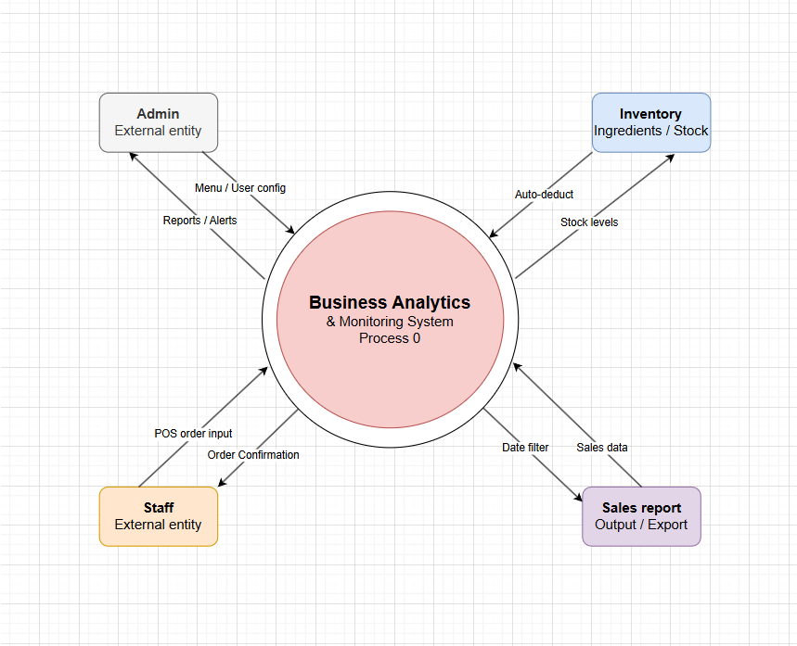

Central Process — Business Analytics & Monitoring System (Process 0)

- The core of the entire system
- Receives inputs from Admin and Staff
- Processes orders, updates inventory, and generates sales reports
- Acts as the "brain" that connects all external entities

Admin — External Entity

- Sends Menu / User config → to the system (sets up menus, user roles, and configurations)
- Receives Reports / Alerts ← from the system (gets notified of performance and issues)

Staff — External Entity

- Sends POS order input → to the system (enters customer orders via Point-of-Sale)
- Receives Order Confirmation ← from the system (gets confirmation that the order was recorded)

Inventory — Ingredients / Stock

- Receives Auto-deduct ← from the system (stock is automatically reduced when an order is placed)
- Sends Stock levels → back to the system (reports current ingredient/stock availability)

Sales Report — Output / Export

- Receives Sales data ← from the system (collects all processed transaction data)
- Sends Date filter → to the system (allows filtering of reports by specific date ranges)
- Used for monitoring, decision-making, and exporting business performance data

Entity Relationship Diagram (ERD)
This diagram is an Entity-Relationship Diagram (ERD) for a cafe management or Operlytics system. It outlines how data is structured and shared between users, orders, menu items, and inventory.
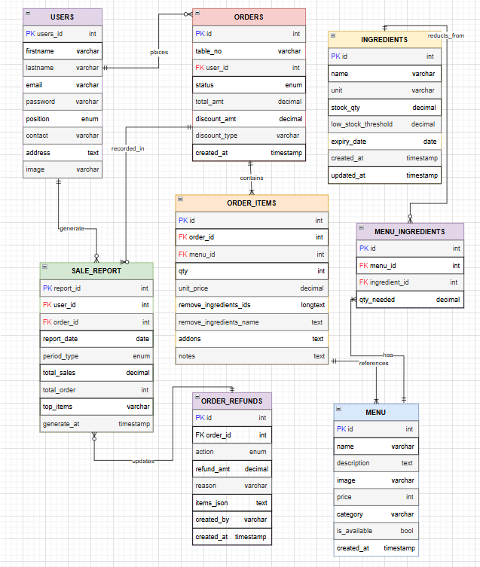

Entities and Their Attributes
- USERS Stores the account information of all system users including administrators and staff. Key attributes include users_id, firstname, lastname, email, password, position, contact, address, and image.
- ORDERS Records all customer orders placed within the café. Key attributes include id, table_no, user_id, status, total_amt, discount_amt, discount_type, and created_at.
- ORDER_ITEMS Stores the individual items included in each order. Key attributes include id, order_id, menu_id, qty, unit_price, remove_ingredients_ids, remove_ingredients_name, addons, and notes.
- ORDER_REFUNDS Tracks refund transactions associated with specific orders. Key attributes include id, order_id, action, refund_amt, reason, items_json, created_by, and created_at.
- MENU Contains the list of available café products and their details. Key attributes include id, name, description, image, price, category, is_available, and created_at.
- MENU_INGREDIENTS Serves as a junction table linking menu items to their required ingredients. Key attributes include id, menu_id, ingredient_id, and qty_needed.
- INGREDIENTS Manages the café's inventory of raw ingredients and supplies. Key attributes include id, name, unit, stock_qty, low_stock_threshold, expiry_date, created_at, and updated_at.
- SALE_REPORT Stores generated sales reports summarizing operational performance. Key attributes include report_id, user_id, order_id, report_date, period_type, total_sales, total_order, top_items, and generate_at.

Relationships
- USERS → ORDERS A user places one or many orders. This is a one-to-many relationship, where one user account can be associated with multiple order transactions.
- USERS → SALE_REPORT A user generates one or many sale reports. This is a one-to-many relationship, where a single user can produce multiple generated reports over time.
- ORDERS → ORDER_ITEMS An order contains one or many order items. This is a one-to-many relationship, as each order transaction may include multiple individual menu items.
- ORDERS → ORDER_REFUNDS An order may be associated with a refund transaction. This is a one-to-one or one-to-many relationship, where a single order can have one or more associated refund records.
- ORDERS → SALE_REPORT An order is recorded in a sale report. This is a many-to-one relationship, where multiple orders may be consolidated into a single generated report.
- SALE_REPORT → ORDERS A sale report updates based on order data. This reflects a many-to-one dependency where report summaries are derived from accumulated order records.
- ORDER_ITEMS → MENU Each order item references a menu item. This is a many-to-one relationship, where multiple order items can correspond to the same menu entry.
- MENU → MENU_INGREDIENTS A menu item has one or many ingredient requirements. This is a one-to-many relationship linking each menu product to the ingredients needed for its preparation.
- MENU_INGREDIENTS → INGREDIENTS Each menu ingredient entry references a specific ingredient in the inventory. This is a many-to-one relationship, where multiple menu items may require the same ingredient.
- INGREDIENTS → ORDER_ITEMS Ingredients are deducted from inventory based on order items processed. This reflects the auto-deduction relationship where completed orders trigger automatic stock reduction in the ingredients table.

The database schema of Operlytics, composed of eight entities and nine defined relationships, establishes a comprehensive and logically structured data management foundation that directly supports the system's core operational objectives. The careful design of entity relationships ensures referential integrity across all interconnected tables, minimizing the risk of data inconsistencies that could compromise the accuracy of sales records, inventory levels, and generated reports. By aligning the database structure with the actual operational workflows of Empress Café Boracay, the schema enables Operlytics to process, store, and retrieve business data in a manner that is both efficient and reflective of real café operations, ultimately providing management with a reliable and well-organized data environment upon which sound and informed business decisions can be consistently made.

Use Case Diagram
This Use Case Diagram shows that the Admin has full control over all system functions including inventory, user management, and reporting while the Staff is restricted to logging in and processing customer orders.
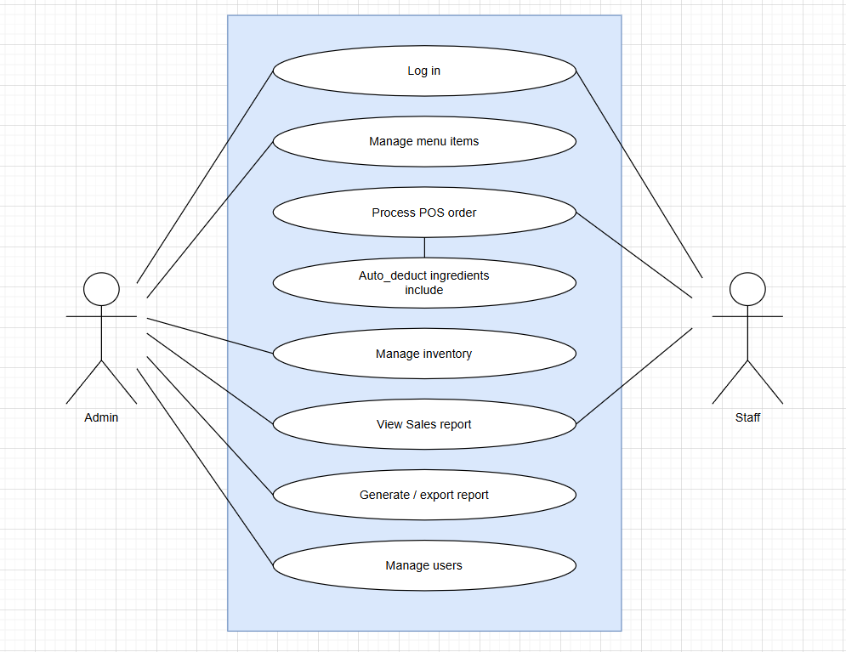

The Operlytics system involves two primary actors the Admin and the Staff each assigned a defined set of system functions that correspond to their respective roles and responsibilities within Empress Café Boracay.
Actors:
Admin — The Admin represents the café manager or authorized administrator who holds full access to the system's operational and managerial functions. The Admin is responsible for overseeing the overall use of the system and has the highest level of access privileges among all system users.
Staff — The Staff represents the café employees who are granted limited but essential access to the system for the purpose of carrying out their daily operational tasks, particularly those related to sales transactions and inventory movement.
Use Cases:
Admin:
- Admin can Log in
- Admin can Manage menu items
- Admin can Process POS order
- Admin can Auto-deduct ingredients
- Admin can Manage inventory
- Admin can View sales report
- Admin can Generate / export report
- Admin can Manage users
Staff:
- Staff can Log in
- Staff can Process POS order
- Staff can Auto-deduct ingredients

The defined use cases of the Operlytics system reflect a deliberate and structured approach to role-based access control, ensuring that each actor within the system is granted only the functions necessary to fulfill their specific responsibilities. By assigning comprehensive managerial functions to the Admin and limiting Staff access to core transactional tasks, the system maintains operational security while minimizing the risk of unauthorized data modification or accidental system misuse. The inclusion of key functionalities such as automated ingredient deduction, real-time inventory management, and report generation directly addresses the operational deficiencies previously identified at Empress Café Boracay. Together, these use cases form the functional backbone of Operlytics, establishing a clear and practical framework through which the system will support efficient daily operations, accurate record-keeping, and informed managerial decision-making across all levels of the café's organizational structure.

References
Alomari, M. (2025). Business analytics in the era of big data: Driving informed decision-making. Scientific Research Publishing. https://www.scirp.org/journal/paperinformation?paperid=140393

Arig, S. C., Borbon, E. R., De Guzman, T. C., Reynaldo, K. A., & Melendez, M. L. D. (2025). Point-of-sale system with card reader for HTM Department. International Journal of Research and Innovation in Social Science, 9(2), 2555–2559. https://dx.doi.org/10.47772/IJRISS.2025.9020199

Bienvenido, J. M. T. (2023). An assessment of the usability of the centralized point-of-sale (POS) system for inventory management of Bounty Agro Ventures, Inc. rotisserie operation [Undergraduate thesis, University of the Philippines Los Baños]. University Knowledge Digital Repository. https://www.ukdr.uplb.edu.ph/etd-undergrad/11821

Almansour, A., & Al-Anazi, M. (2025). Business analytics in the era of big data: Driving informed decision-making. Scientific Research Publishing. https://www.scirp.org/journal/paperinformation?paperid=140393

Sharma, R., Mithas, S., & Kankanhalli, A. (2014). Transforming decision-making processes: A research agenda for understanding the impact of business analytics on organisations. European Journal of Information Systems, 23(4), 433–441. https://doi.org/10.1057/ejis.2014.17

Few, S. (2006). Information dashboard design: The effective visual communication of data. O'Reilly. https://archive.org/details/pdfy--fQ3cC8TeDUArgti/page/n5/mode/2up

Islam, M. R. (2024). AI-driven business analytics for operational efficiency. World Journal of Advanced Engineering Technology and Sciences, 12(02), 535–543. https://wjaets.com/sites/default/files/WJAETS-2024-0329.pdf

Kunc, M., & Bäckström, I. (2025). Business analytics in managerial decision-making: Top management perceptions. Measuring Business Excellence. https://doi.org/10.1108/mbe-09-2023-0130

Kunc, M., & Bäckström, I. (2024). Business analytics in managerial decision-making: Top management perceptions. Measuring Business Excellence, 29(1), 1–17. https://www.emerald.com/mbe/article/29/1/1/1241314

Sharma, R., Mithas, S., & Kankanhalli, A. (2014). Transforming decision-making processes: A research agenda for understanding the impact of business analytics on organisations. European Journal of Information Systems, 23(4), 433–441. https://www.tandfonline.com/doi/abs/10.1057/ejis.2014.17

Tanaman, M. T., Baylosis, J. L. A., Abiles, B. J. A., Catungal, M. L. P., & Encarnacion, P. C. (2023). Web-based inventory management system. International Journal of Science and Advanced Information Technology, 12(5), 44–48. https://www.warse.org/IJSAIT/static/pdf/file/ijsait021252023.pdf

(https://doi.org/10.54660/IJSSER.2024.3.1.201-208 )

End of Proposal

Note to the instructors handling this subject

CHED BSIT ALIGNMENT STATEMENT
This capstone project complies with CHED BSIT standards by demonstrating competencies in application development, database management, systems analysis and design, and emerging technologies such as machine learning. The project follows outcomes-based education principles and integrates ethical considerations, user safety, and data privacy.

